VEHICLE VISION - A Driver Authentication System based on IoT and AI
Base paper Title:
Camera and Biometric based Vehicle Monitoring System for Public Safety
Aim:
Aim of the project is to build a vehicle authentication system for public safety using AI and IoT features.
Synopsis:
Most of the times vehicles used in the crime would be a stolen one. To avoid such thefts, we need to increase the vehicle accessing systems. Now days we can start vehicles by drawing patterns, voice commands, biometric sensors, RF car keys, etc., Face recognition is one of the techs among those. Authenticating drivers at the time of engine start will reduce vehicle theft and crime using stolen vehicles. To authenticate drivers at engine start vehicle is connected with internet and every time dataset updated from the server.
We are proposing this model for public vehicles authentication systems. At first, Driver needs to register his data along with photo and vehicle id with the help of manager authentication which will do from the server side. After that, whenever a driver tries to start engine vehicle id is sent to the server. When a vehicle request given by driver, server fetch driver details under vehicle id and send it to the vehicle controller with OTP. Same OTP sends to driver mail id which should be entered by the driver. If OTP matches with server’s one, vehicle controller start to recognize the driver face. If driver face matches with the existing dataset controller will start the engine. Travel logs updated on server side every time car stats. If OPT mismatch or Unknown person tries to start the car notification will send manager.

Existing System:
Existing system uses Raspberry pi 3b+ module along with pi-cam to furnish facial recognition module. Biometric authentication is provided by using r305 module. Both the modules use the common database through which the person’s identification will be checked in the authentication phase. This system with GPS enabled ensures the safety of passengers throughout their journey.
Proposed System:
In proposed system, Raspberry pi only act as vehicle controller. Java server is responsible for Driver registration and database handling. Driver need to request the server every time he starts the vehicle and his travel history will be maintained in log. After request, Driver needs to pass dual authentication i.e OTP and face recognition. This process will ensure the safety of the travel for public.
Modules:
Modules Description:
Manager Registration and User Registration:
The Manager will register driver details with photo ID and Vehicle ID. It will be stored in cloud database.
Stand Alone Face Recognition:
Dataset collection, Training CNN face recognition model and face classification will be done in this module.
Integration of vehicle controller and Server:
In this module connection between the vehicle controller, server and cloud database will be done.

Block Diagram:
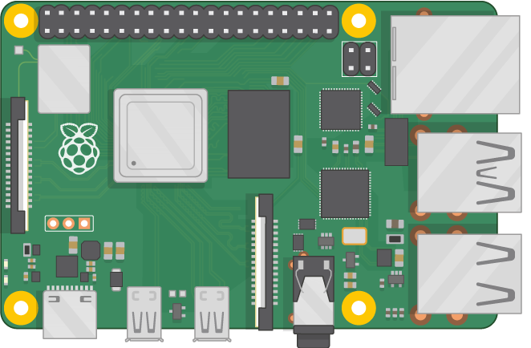
Raspberry Pi
Pi Camera
Engine
Server
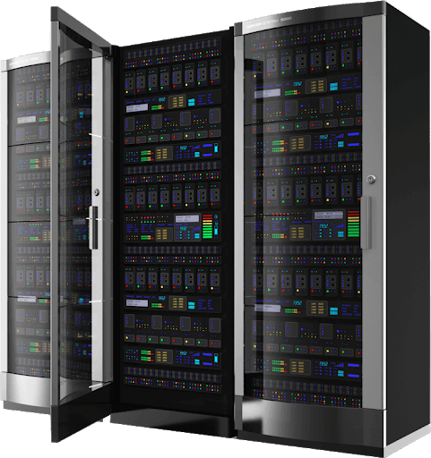
Manager
Cloud Database
Driver

Block Diagram Description:
In the above diagram, Server acts as main controller and raspberry pi act as vehicle controller. Server is responsible for Driver registration, Vehicle request handling, and Database maintenance. Raspberry pi is responsible for capturing images, face recognition and engine control.

Hardware Requirements:
- Raspberry Pi
- Raspberry pi camera
- Relay
- DC Motor
- Push Button
Software Requirements:
- Language : Python, JAVA
- Compiler : GCC Complier.
- OS : Linux, Windows 7 and above(64 bit)
- JDK 1.8
- Tomcat 8.5
- MySQL

